HOW TO UPLOAD TO GITHUB

1. Download Github for Windows

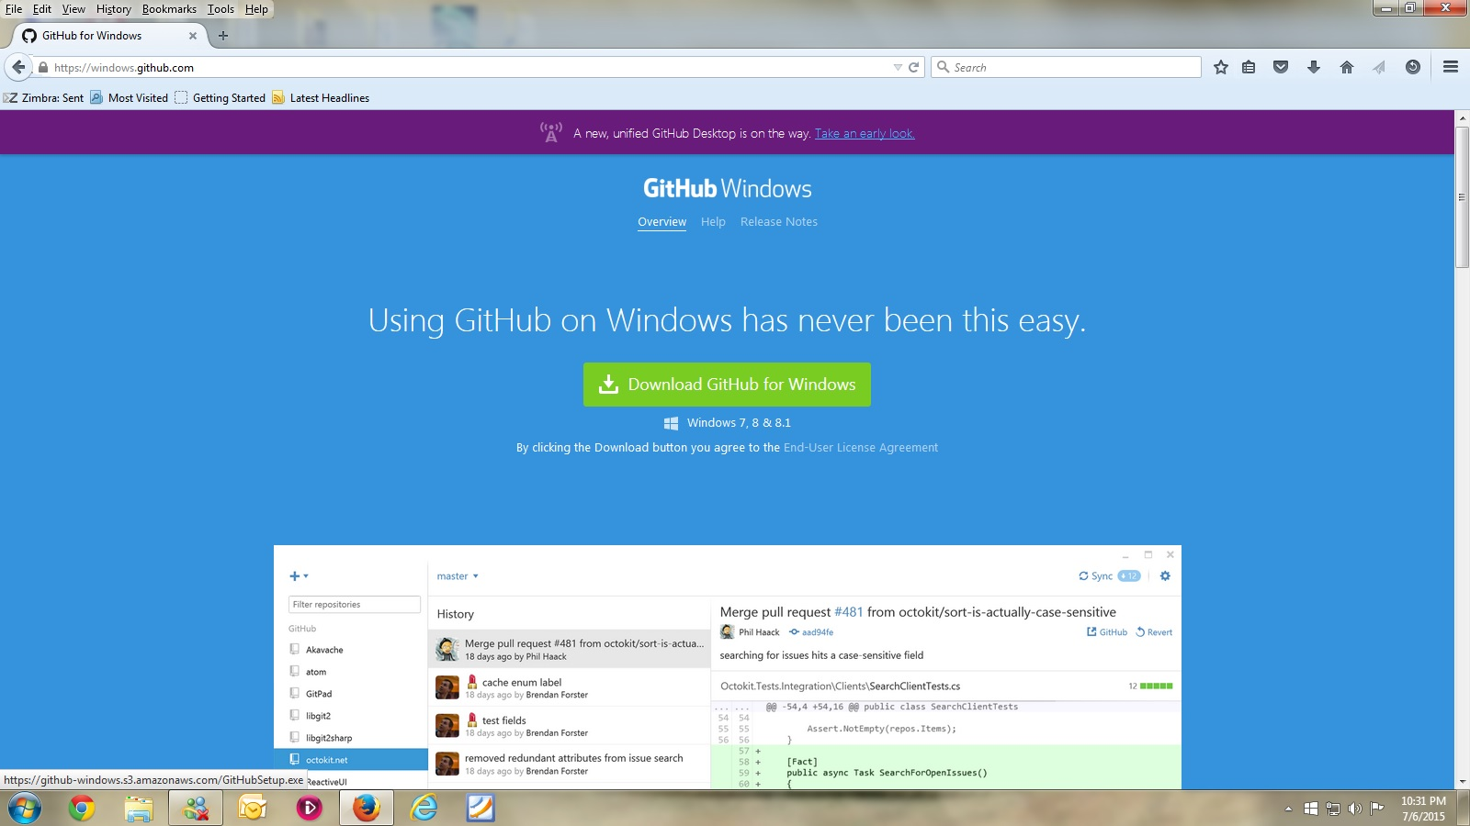

2. Save File

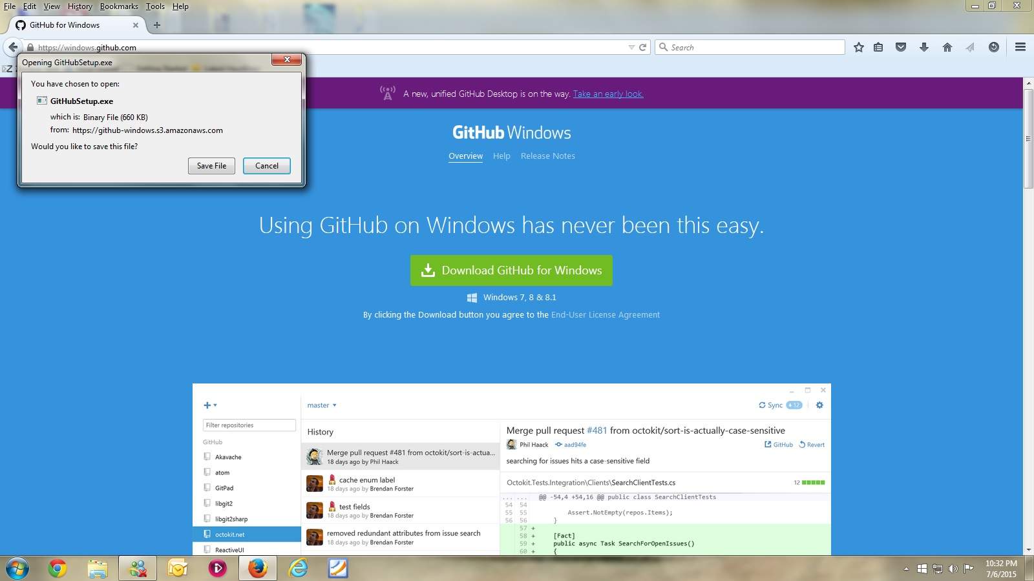

3. Double Click

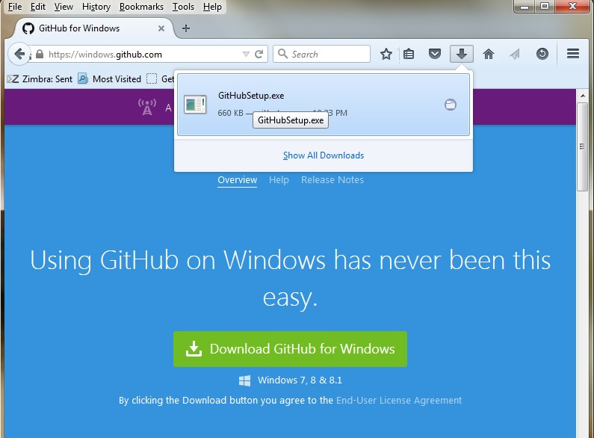

4. Run

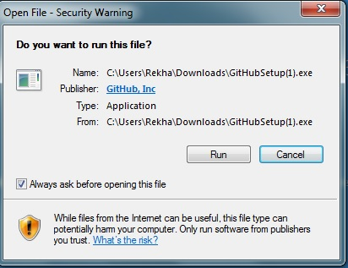

5. Click Install

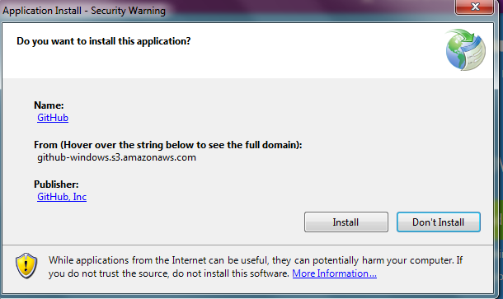

6. Installation Starts

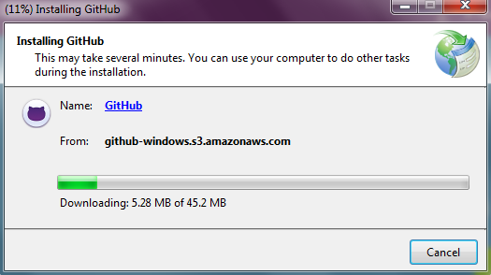

7. Notice these icons on your desktop

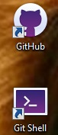

8. Github For Windows Opens up.

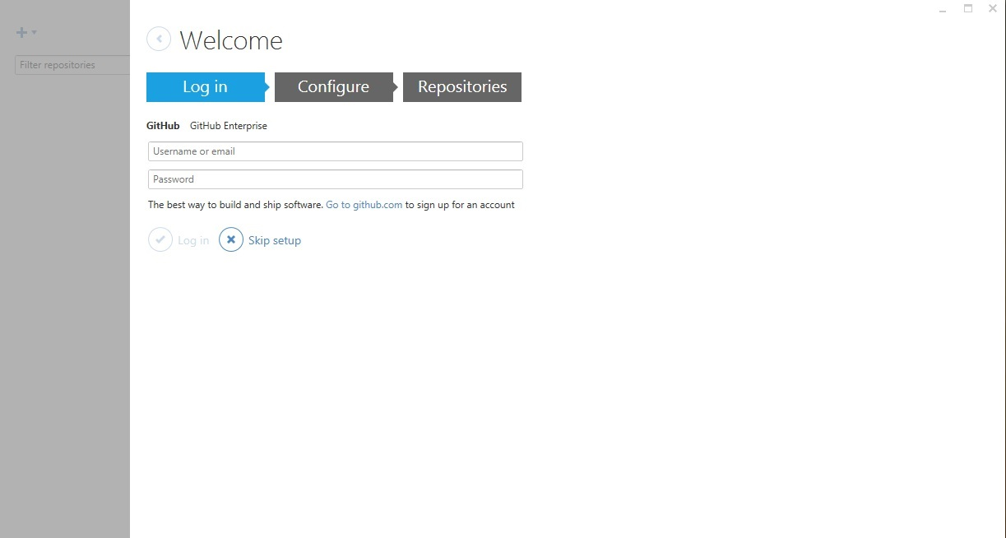

9. Notice these icons on your desktop.

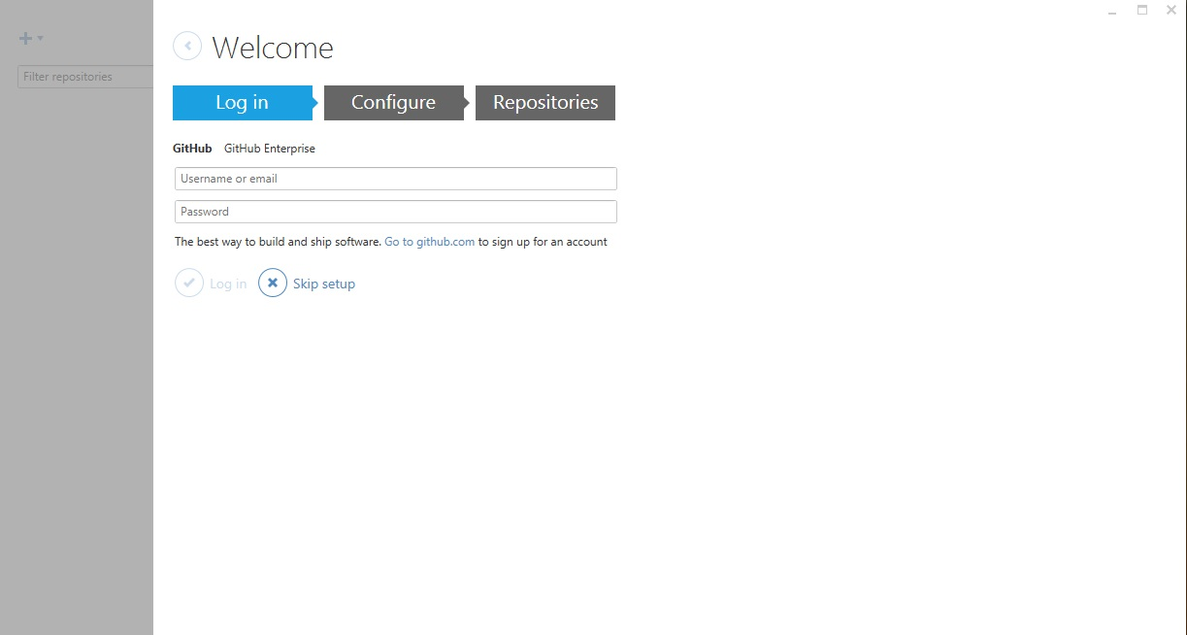

10. Login with your Github email address (FAU) and PW.

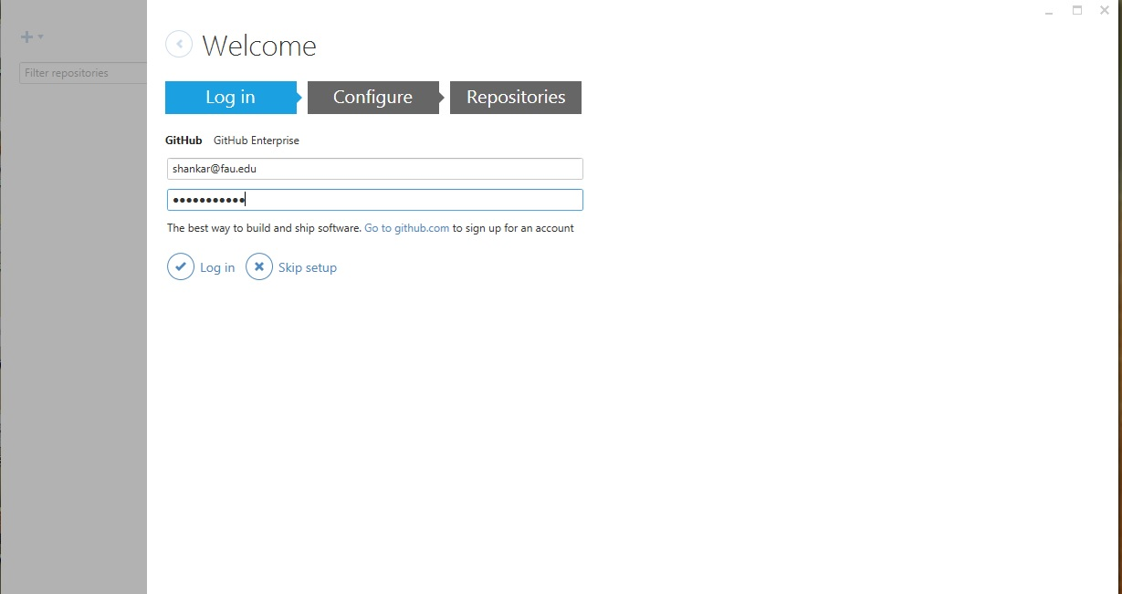

11. Click Continue

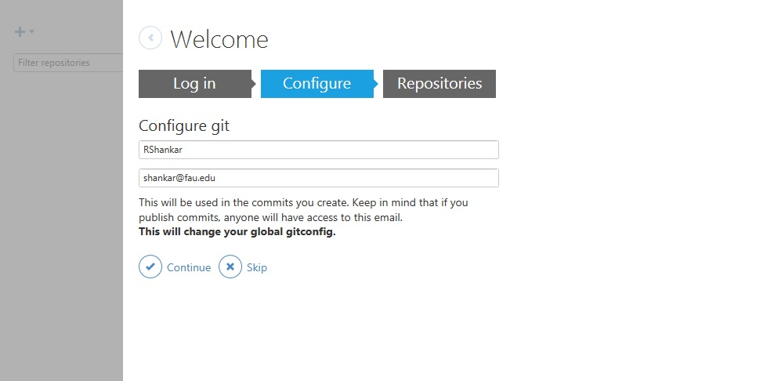

12. Click on dashboard.

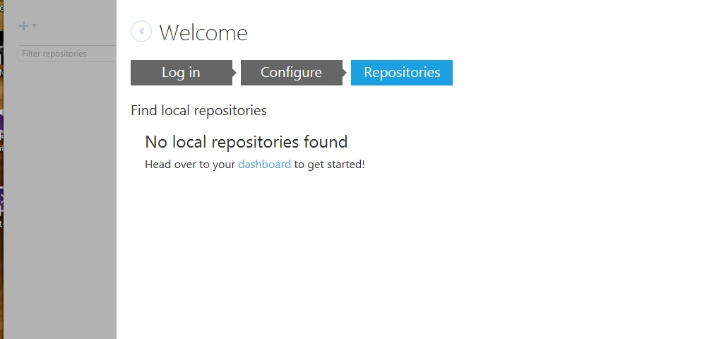

13. See this screen.

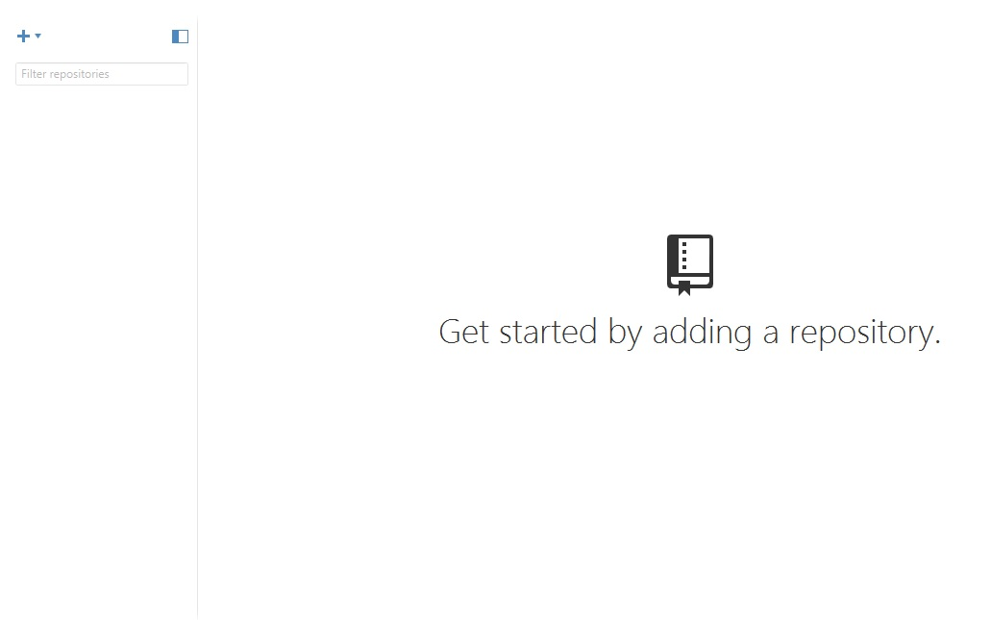

14. Go to MODSApps -- Information at Github.

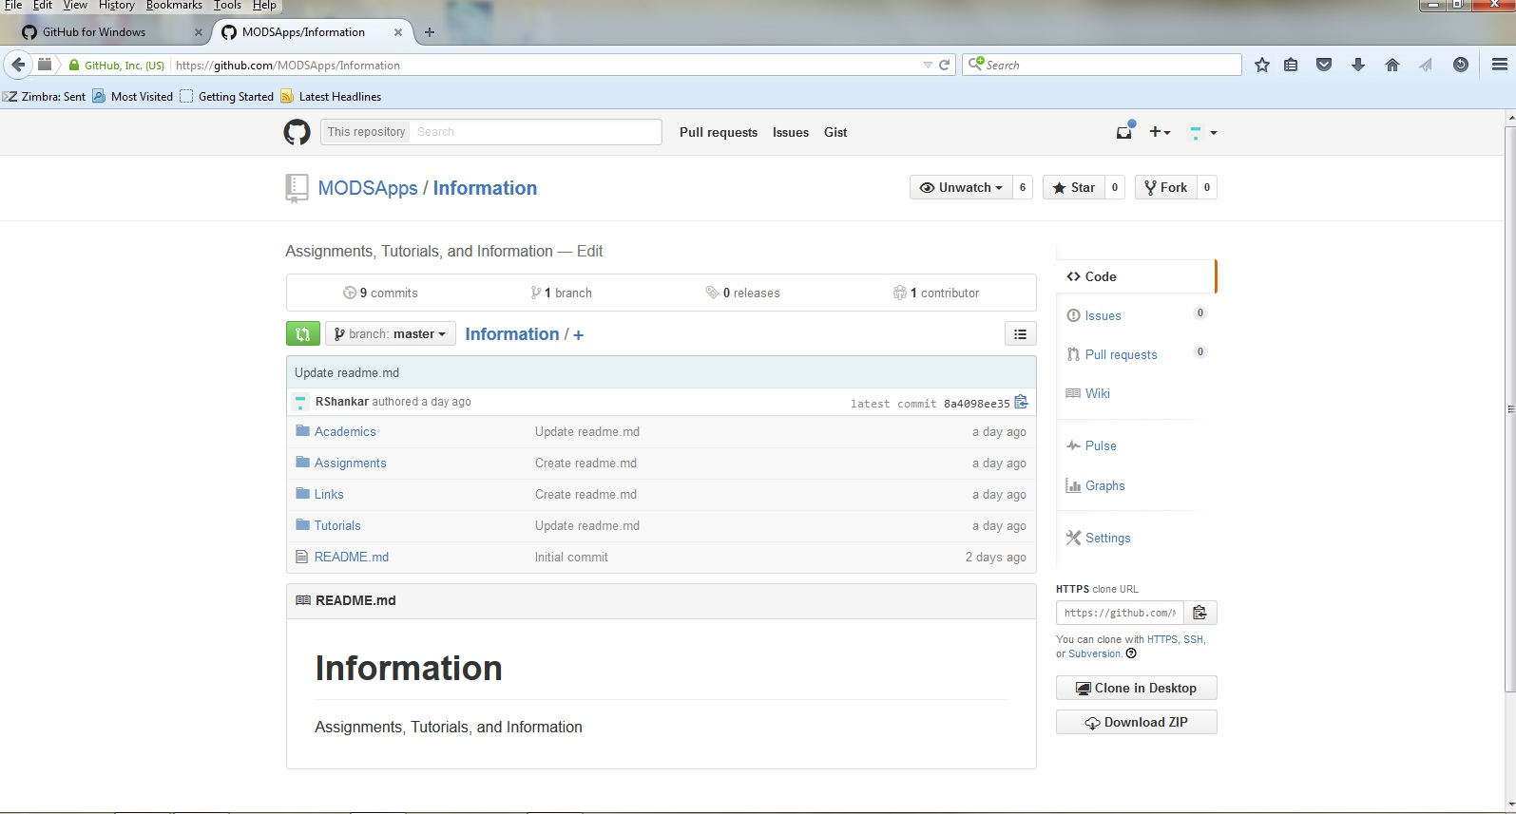

15. I clicked on Clone. Check on Remember and OK.

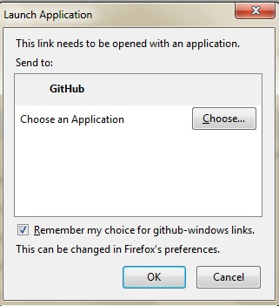

16. Notice the GitHub folder under MyDocuments. Click OK.

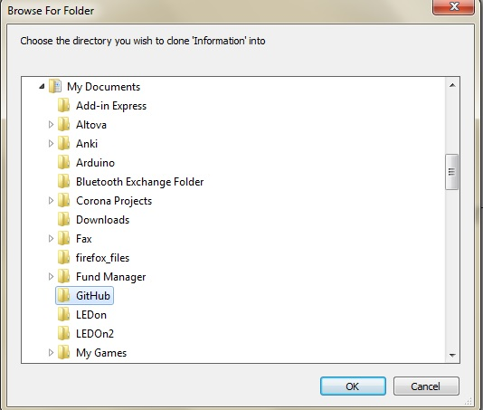

17. Go the Folder.

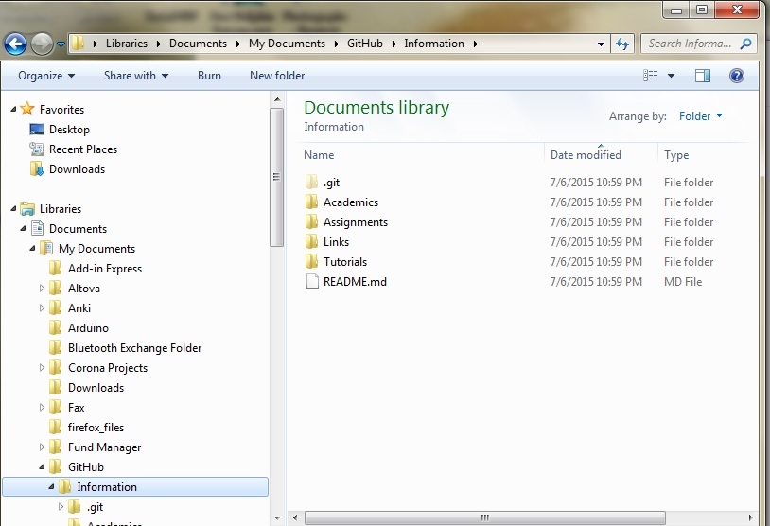

18. Notice only readme.md in your folder.

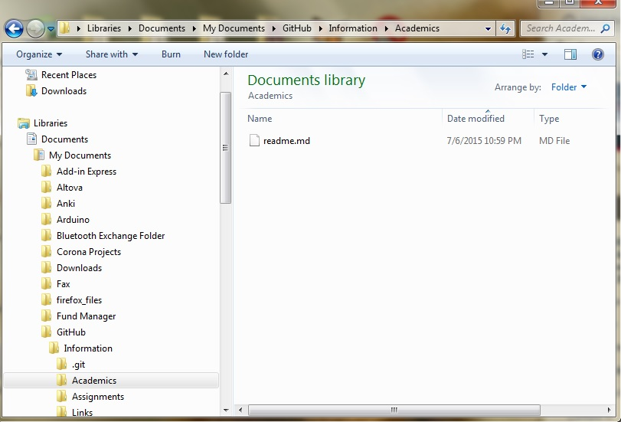

19. Add folders that you wish to commit. You can revise there here itself. Commits will track revisions.

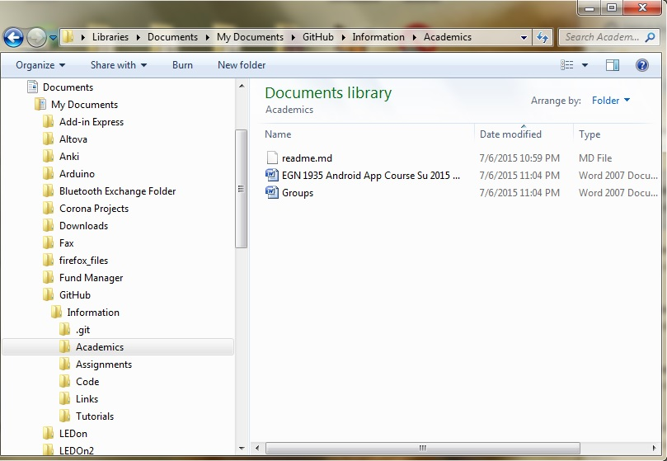

20. Open Github for Windows - notice that all uncommitted changes appear automatically here.

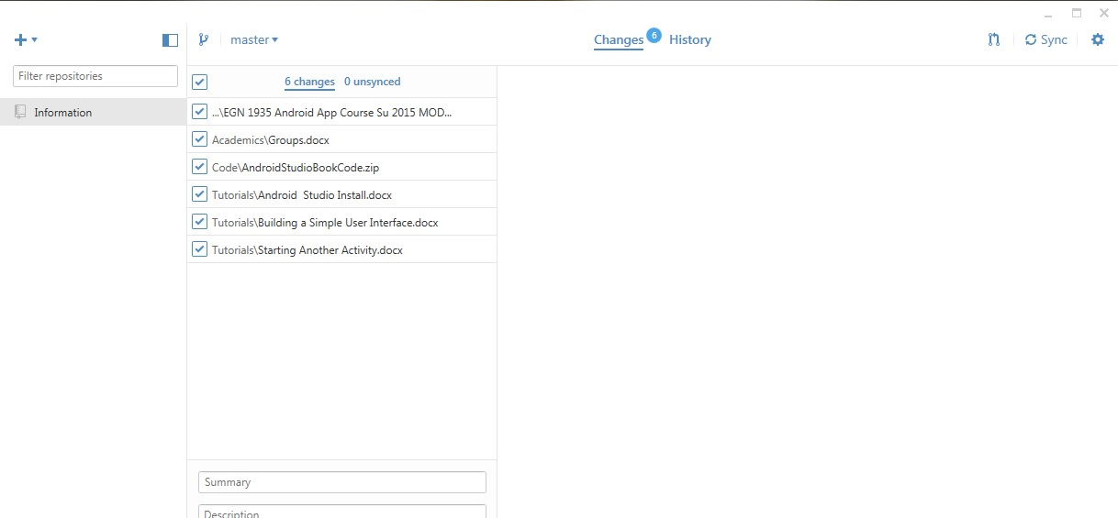

21. Fill out the summary and Details windows with relevant info and click 'Commit to master'.

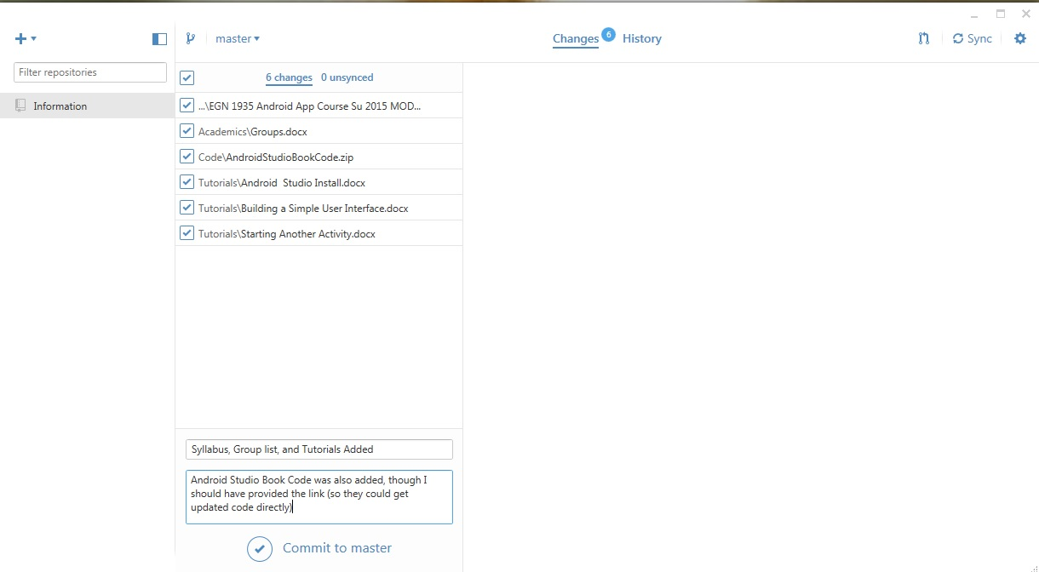

22. Note the commit to the github site is ready - see the blue banner at the bottom. Click the Synch at the right top to upload to Github site.

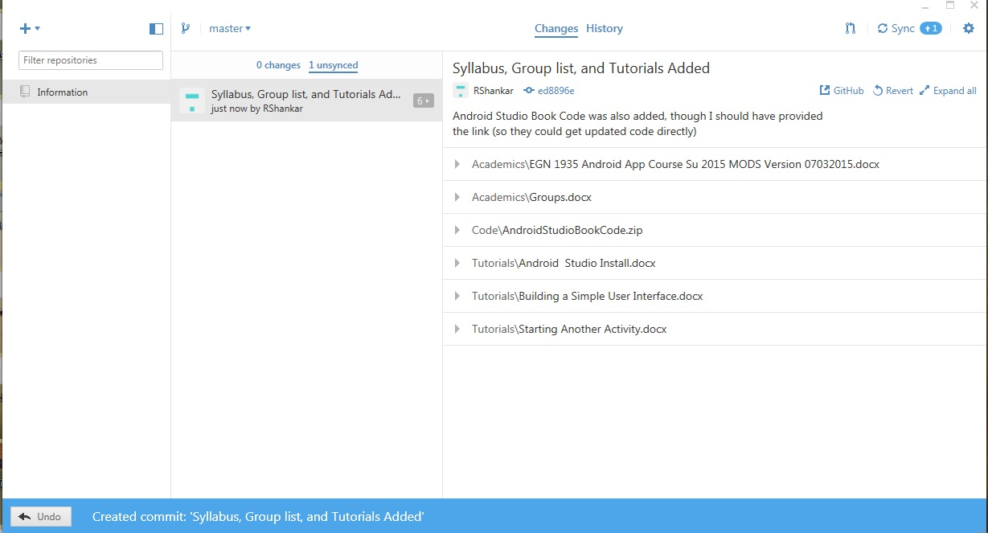

23. After a while it shows that is synched.

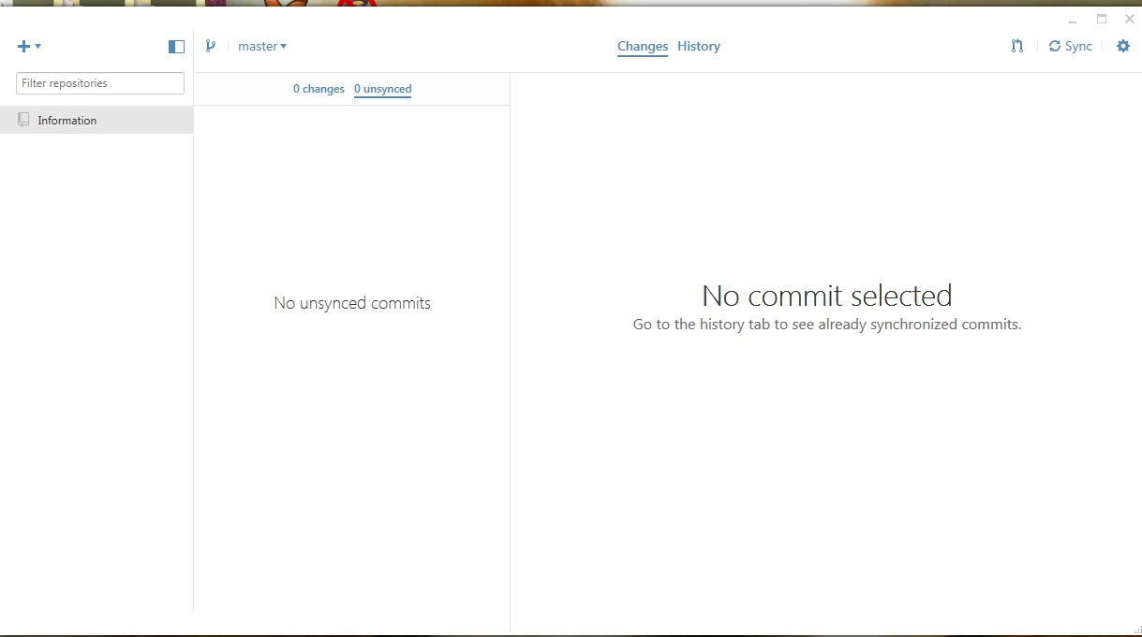

24. Verify that Github site has the update.

